Fig. <$n:figure:SyncVsAsync_SyncControlFlow> shows the control flows for code versions 1 and 2.

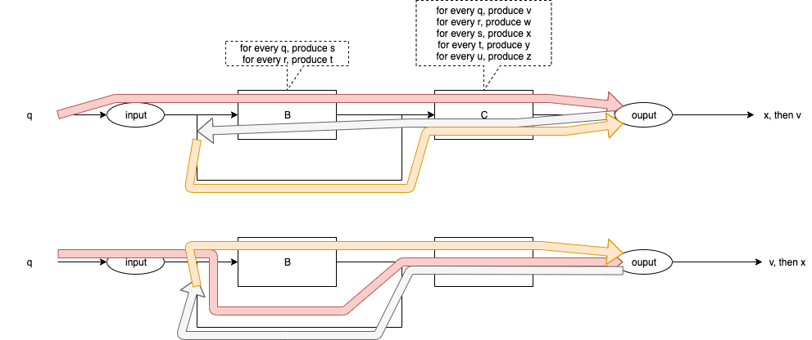

Fig. <$n:figure:SyncVsAsync_SyncControlFlow> Control Flow for Versions 1 & 2

